West Virginia Perinatal Summit
Catalyzing Change:
The CHAMPS National Initiative in West Virginia

Presented by: Cathy Carothers, IBCLC, FILCA
Every Mother, Inc.
cathy@everymother.org

Disclosures:
- Mississippi CHAMPS trainer and hospital coach
- CHAMPS National trainer and hospital coach
- Project Director, WIC Breastfeeding Curriculum

Objectives:
- Identify inequities in breastfeeding support among underserved populations.
- Describe CHAMPS National approaches for reducing disparities within hospital maternity care practices and breastfeeding rates.
- Name ways targeted data collection can assist in implementing practice changes to improve breastfeeding rates.
Breastfeeding Matters!
- The perfect food for newborns - specifically designed for the growth and development needs of human babies and tailored to the unique needs of each individual baby.
- Perfect nutrition...and medicine for the newborn, with living cells and infection-fighting ingredients to protect the infant from illness and disease.
- More than 100,000 constituents that work together to influence growth, development, and immune status of the infant.
- Infant thymus (central organ to the immune system) is significantly larger than the thymus of formula-fed infants

When Low-Income Parents Begin Supplementing
- Supplementing often begins in the hospital and the early days postpartum. By 2 weeks, half of WIC infants are already receiving formula. Most began supplementing by day 5.
- Reasons vary and include such factors as:
- Returning to work or school
- Worries about milk production
- Lack of understanding how the body works to make milk
- Not understanding or misinterpreting their baby’s behaviors
- Medical conditions (e.g., maternal insufficient glandular tissue or infant weight issues)
- Inequities among underserved populations
[USDA WIC Infant and Toddler Feeding Practices Survey, 2016]

Cathy’s Definition of “Informed Decision-Making”
- WHY…breastfeeding is important for both infant and maternal health
- HOW…to make it work, and how to fit it into the parent’s life
- WHAT…to expect (e.g., feeding frequency, cluster feeding, growth spurts, etc.)
- WHERE…to get support at the hospital and in the community post-discharge

Key Hospital Practices that Make a Difference
- Prenatal education (Step 3)
- Skin-to-Skin Care (Step 4)
- Breastfeeding technique (position/latch) (Step 5)
- Rooming-in (Step 7)
- Avoiding formula and artificial nipples (Steps 6 and 9)
- Discharge education and support (Step 10)

Mississippi CHAMPS
- Community engagement and partnership building
- Training
- One-on-one coaching and step-by-step navigation through the 10 Steps and Baby-Friendly process
- Data collection to identify breastfeeding gaps and disparities and inform practice changes
- Successes
  - 0 to 30 of state’s 39 delivering hospitals now designated Baby-Friendly
  - 88% of Mississippi infants now born in a Baby-Friendly hospital
  - Increases in initiation and exclusivity rates – especially in W.K. Kellogg’s “areas of interest” (areas with high infant mortality and poverty rates)
  - Narrowing the gap in disparities
  - Dramatic improvements in maternity care practices
CHAMPS National Initiative in West Virginia
- Funded through a cooperative agreement with the Centers for Disease Control and Prevention
- Project goals:
- Increase breastfeeding rates (especially exclusive rates)
- Decrease disparities
- Implementation of the Ten Steps to Successful Breastfeeding
- 100 hospitals enrolled (including 7 West Virginia hospitals)
- Cabell Huntington
- Charles Area Medical Center
- WVU Medicine Camden-Clark
- WVU Medicine Children’s
- WVU Medicine Princeton
- WVU Medicine Reynolds
- WVU Medicine Thomas

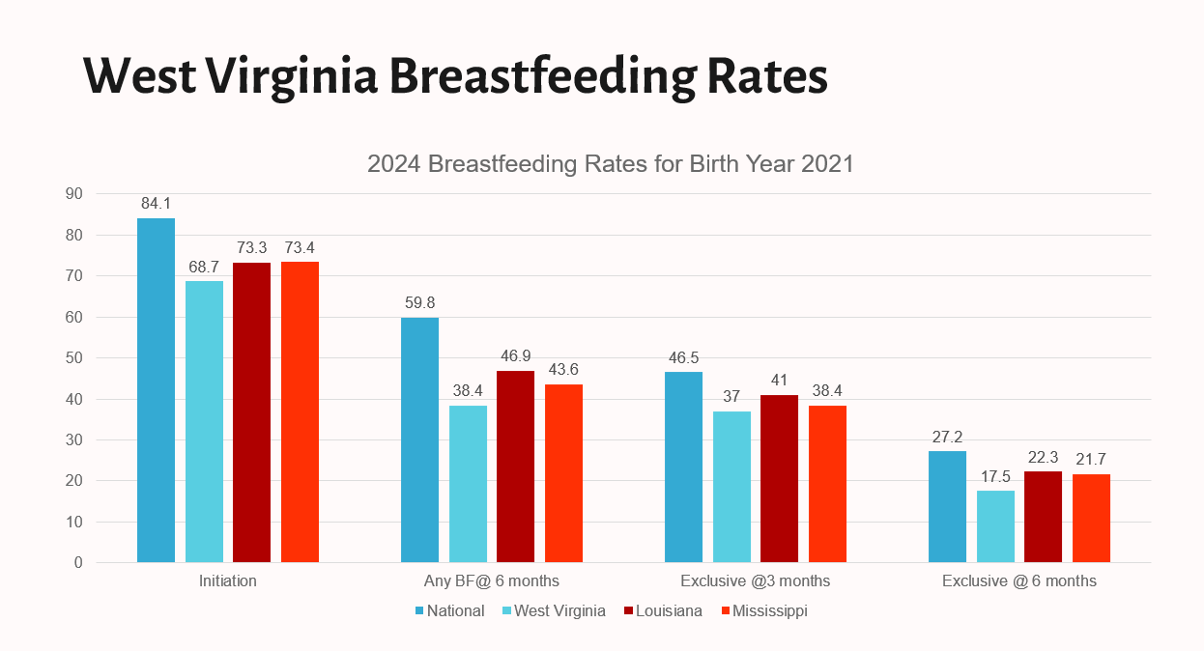

- Tailored coaching (Cathy Carothers is the WEST VIRGINIA CHAMPS National coach)
- STEPS Teams - opportunity for WIC engagement
- Community collaboration
- West Virginia WIC Program – Kara Napier, WV WIC State Breastfeeding Coordinator
Kara.D.Napier@wv.gov
304-352-0968
- Data collection
- Breastfeeding initiation
- Breastfeeding exclusivity
- Skin-to-skin after vaginal birth
- Skin-to-skin after cesarean birth
- Rooming-in
- CHAMPS Training opportunities:
- CHAMPS National Training – Unit 1, Session 1, “Do We Hear You?” – October 25, 2024, 3-4:30 p.m. ET. Register at: champs.breastfeed@gmail.com
- Inter Professional Education Module (IPE) - Breastfeeding: Human Medicine. A 3-hour online module for everyone (providers, nurses, WIC staff, social workers, and community) - https://breastfeeding.inspire-health.org/

Hospital Action Items
- Identify gaps and goals
- Improve staff education
- Certified Breastfeeding Specialist (CBS) – through Lactation Education Resources at https://www.lactationtraining.com/cbs-info
- Lactation Counselor Training Course – through Healthy Children Project at https://centerforbreastfeeding.org/education/lactation-courses-2/
- IABLE – Institute for the Advancement of Breastfeeding and Lactation Education at https://lacted.org/
- Academy of Breastfeeding (ABM) “What Every Physician Needs to Know (Parts 1 and II) at https://www.bfmed.org/2024-annual-meeting-schedule-at-a-glance
- CHAMPS website for archived recordings of webinars, trainings, and conference sessions at https://cheerequity.org/champsnational/events/
- Focused patient education seizing on teachable moments
- Establish a structured referral network.
- Assume the best!
- Celebrate the victories!

Resources
- Center for Health Equity, Education, and Research: https://cheerequity.org/
- CHAMPS National: https://cheerequity.org/champsnational/
- Ten Steps to Successful Breastfeeding: https://www.who.int/teams/nutrition-and-food-safety/food-and-nutrition-actions-in-health-systems/ten-steps-to-successful-breastfeeding
- Baby-Friendly USA: https://www.babyfriendlyusa.org/
- USDA Food and Nutrition Service VIDEO: Partnering with WIC for Breastfeeding Success. https://wicbreastfeeding.fns.usda.gov/video-partnering-wic-breastfeeding-success



Cathy Carothers
Email: cathy@everymother.org
Every Mother Website: www.everymother.org
Every Mother Facebook: Every Mother, Inc.
Personal Facebook: Cathy Carothers

References
Agency for Healthcare Research and Quality. Breastfeeding and maternal and infant health outcomes in developed countries. Washington, D.C.: Agency for Healthcare Research and Quality, 2007. Available at www.ahrq.gov.

Agency for Healthcare Research and Quality. Breastfeeding Programs and Policies, Breastfeeding Uptake, and Maternal Health Outcomes in Developed Countries: Comparative Effectiveness Review No. 210. Rockville, MD: Agency for Healthcare Research and Quality, Publication No. 18-EHC-014-EF, July 2018. Available at https://effectivehealthcare.ahrq.gov/sites/default/files/pdf/cer-210-breastfeeding-report_1.pdf.

American Academy of Pediatrics. Policy statement: Breastfeeding and the use of human milk. Meek J, Noble L. Pediatrics. 2022;150(1). Available at https://publications.aap.org/pediatrics/article/150/1/e2022057988/188347/Policy-Statement-Breastfeeding-and-the-Use-of?autologincheck=redirected.

Cerini C, Aldrovandi G. Breast Milk: Proactive Immunomodulation and Mucosal Protection Against Viruses and Other Pathogens. Future Virology. 2013; 8(11):1127-1134. Available at http://www.medscape.com/viewarticle/814970_2.

Golinelli LP, Del Aguila EM, Flosi Paschoalin VM, Silva JT, Conte-Junior CA. Functional aspect of colostrum and whey proteins in human milk. J Hum Nutr Food Sci. 2014;2(3):1035.

Guesnet P, Alessandri JM. Docosahexaenoic acid (DHA) and the developing central nervous system (CNS) - Implications for dietary recommendations. Biochimie. 2011;93(1):7-12.

Hakansson A, Zhivotovky B, Orrenius S, Sabharwal H, Svanborg C. Apoptosis induced by a human milk protein. Natl. Acad. Sci. 1995;92(17):8064-8068.

Khan S, Hepworth AR, Prime DK, Lai CT, Trengove NJ, Hartmann PE. Variation in fat, lactose, and protein composition in breast milk over 24 hours: associations with infant feeding patterns. J Hum Lact. 2013;29(1):81-9.

Pannaraj PS, Li F, Cerini C, Bender JM, Yang S, et al. Association between breast milk bacterial communities and establishment and development of the infant gut microbiome. JAMA Pediatr. 2017;171(7):647-654.

USDA Food and Nutrition Service. May L, Borger C, McNutt S, et al. WIC Infant and Toddler Feeding Practices Study 2: Intention to Breastfeed, 2017. Available at https://fns-prod.azureedge.net/sites/default/files/ops/WIC-ITFPS2-Infant.pdf.
USDA Food and Nutrition Service. Website: WIC Breastfeeding Support. Community Partnerships. https://wicbreastfeeding.fns.usda.gov/video-creating-community-partnerships-wic-breastfeeding-success

Wambach K, Spencer B. Breastfeeding and Human Lactation. Burlington, MA: Jones & Bartlett Learning, 2023.

